**Assignment-1**

Implement the Hospital Database and execute the given queries:

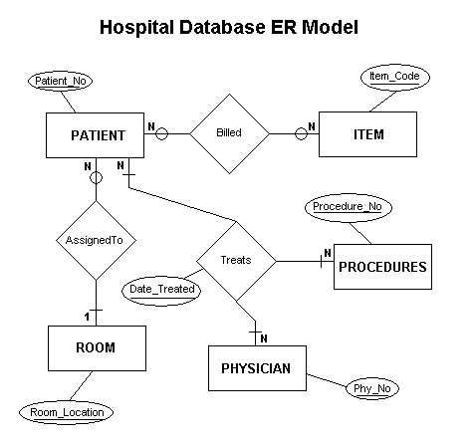

Relations (Include all the necessary integrity constraints):

|  |  |
| --- | --- |
| BILLED |  |
| BILL NO | NUMBER(5) - PRI KEY |
| PATIENT_NO | NUMBER(9) |
| ITEM_CODE | NUMBER(5) |
| CHARGE | NUMBER(7,2) |

|  |  |
| --- | --- |
| TREATS |  |
| PHY_ID | NUMBER(4) - PRI KEY |
| PATIENT_NO | NUMBER(4) - PRI KEY |
| PROCEDURE_NO | NUMBER(4) - PRI KEY |
| DATE_TREATED | DATE - PRI KEY |
| TREAT_RESULT | VARCHAR2(50) |

|  |  |
| --- | --- |
| ITEM |  |
| ITEM_CODE | NUMBER(4) - PRI KEY |
| DESCRIPTION | VARCHAR2(50) |
| NORMAL_CHARGE | NUMBER(7,2) |

|  |  |
| --- | --- |
| PHYSICIANS |  |
| PHY_ID | NUMBER(4) - PRI KEY |
| PHY_PHONE | CHAR(8) |
| PHY_NAME | VARCHAR2(50) |

|  |  |
| --- | --- |
| PATIENT |  |
| PATIENT_NO | NUMBER(4) - PRI KEY |
| DATE_ADMITTED | DATE |
| DATE_DISCHARAGED | DATE |
| PAT_NAME | VARCHAR2(50) |
| ROOM_LOCATION | CHAR(4) |

|  |  |
| --- | --- |
| ROOM |  |
| ROOM_LOCATION | CHAR(4) - PRI KEY |
| ROOM_ACCOMODATION | CHAR(2) |
| ROOM_EXTENSION | NUMBER(4) |

|  |  |
| --- | --- |
| PROCEDURES |  |
| PROCEDURE_NO | NUMBER(4) - PRI KEY |
| PROC_DESCRIPTION | VARCHAR2(50) |

**Implement the following queries (Use Hospital_DB.sql to populate the DB):**

1. Get the **PATIENT_NO**, **ITEM_CODE**, and **CHARGE** and from the **BILLED** table for a specific **PATIENT_NO**
2. List all of the different charges that are stored to the table
3. Display all columns and all rows from the **BILLED** table
4. Display all **charges** greater than Rs. **5.00** for the **PATIENT_NO 1116**
5. Display all **charges** for either patient 1116 or patient 1117
6. Count the number of times patient 1116 has been charged for items
7. Display number of **DISTINCT** procedures performed on a patient
8. Give a meaningful column name for number of **DISTINCT** procedures in the above query
9. Display a calculated value such as the current charge and the amount that would be charged if the charge were increased by 6% for all rows in the **ITEM** table
10. List all patients hospitalized more than 6 days
11. List the total charges per patient for expensive medical items (**CHARGE** greater than Rs100 for an item) where patients owe the hospital a  sum (total charges over Rs500)
12. List the patients who had either Dr. Hawkeye Pierce or Dr. Trapper John or Dr. Jonas Salkman as a physician
13. Show the patient names (**PAT_NAME** field) and associated physician names (**PHY_NAME** field) along with the Patient information
14. List the **PATIENT_NO** and **DATE_DISCHARGED** from the **PATIENT** table and the associated **CHARGE** from the **BILLED** table.